Division: Glass Construction | Date: 2020/11/17 | Text and photo: www.der-pressedienst.de/architektur-bauen/intl-architecture/

How complex facade concepts and bird protection can be optimally combined with ORNILUX®

Bird protection for all requirements

Arnold Glas expands on the Ornilux product range / Practical experience of bird protection spanning more than 20 years / Advising architects and building planners on the optimal use of Ornilux / AIA accredited presentation

In order to reduce bird strikes on buildings, legal requirements for bird friendly glass have been introduced in many US cities to reduce the number of bird window collisions. With the Ornilux product range, Arnold Glas offers various certified transparent and visible bird protection glass solutions that enable Architects to design bird friendly buildings without compromising on aesthetics and quality views. Drawing on a unique data pool acquired from multiple projects implemented around the world, Arnold Glas can advise architects and planners on the design of bird-friendly facades.

Researchers estimate that hundreds of millions of birds are killed each year in North America due to collisions with glass on human-built structures, making bird collisions one of the most significant causes of avian mortality globally. As a result of these findings, first legal requirements governing the urban land-use planning of cities and municipalities were introduced in 2012, which commit these districts to investigate bird strikes on buildings within the framework of nature conservation regulations, and to reduce the risk of these occurring. Under the provisions of these regulations, architects and building planners are required to adopt a bird-friendly approach when developing their projects.

With the understanding that birds are able to see light in the ultraviolet spectrum, bird-friendly glass innovator, Arnold Glas developed Ornilux bird protection glass, the first word-wide transparent bird protection glass, in 2006. The glass has a patterned, UV-reflective coating making it visible to birds while remaining virtually transparent to the human eye.

Comprehensive data pool on bird protection
Since the introduction of the coating, a huge pool of data and wealth of experience have been acquired through extensive tests, the realisation of more than 250 projects worldwide and the corresponding monitoring of individual projects, which also incorporate scientific knowledge obtained to date from global collaborations with institutes and nature conservation organisations, including such well-known names as the American Bird Conservancy (ABC), the Vienna Ombuds Office for Environmental Protection (Austria) and, among others, the ornithological station in Radolfzell (Germany), which was the first to examine the behaviour of birds in flight tunnels using various glass coatings. The results obtained from more than 20,000 approaches by 50 different bird species are unique across the globe. The effectiveness of Ornilux was confirmed during a monitoring project at the University of Utah (USA).

Based on the results of this wide-ranging research, Arnold Glas has consistently developed its portfolio in recent years. Today, the Group offers its customers two different categories of Ornilux, which meet the diverse requirements governing certified bird protection: Ornilux mikado and Ornilux design.

Ornilux mikado – transparent solutions for bird protection
With Ornilux mikado, Arnold Glas succeeded in applying a UV reflective coating in a spider web-like pattern to glass making it visible to most birds while maintaining virtually transparent to the human eye. This idea draws on inspiration from nature – a so-called biomimicry – an approach to innovation that seeks sustainable solutions to human challenges by emulating nature’s time-tested patterns and strategies. Ornilux mikado adopts this principle, thus allowing for aesthetically pleasing and transparent façade concepts while extending the definition of an environmentally friendly glass type to wildlife conservation. Ornilux mikado can be used in all windows and facades as a conventional insulating or laminated safety glass. Other functions such as solar control are integrated. Particularly in the USA, where bird-friendly facade design has been legally codified for some time, Ornilux mikado has repeatedly demonstrated its effectiveness.

This bionic technology is also used in Ornilux mikado ONE. One of the aims of this new development was to modify the coating so that it is resistant to the exposure to the elements and therefore ideal for use on the outside glass surface (surface 1) which has become an increasingly important factor when working in the Canadian market where this product meets the requirements of this market. In addition, the virtually invisible web-like pattern effectively breaks up reflections on the surfaces, which also contributes towards reducing bird strikes.

From a manufacturing perspective, a crucial advantage of this surface one coating is that low-emissivity coatings can be added at the subsequent surface 2 making it a cost effective solution.

Ornilux design – visible solutions for bird protection
The latest addition to the Ornilux product range is Ornilux design. With this bird protection glass, the developers adopted a different approach by equipping the panes with a visible metallic coating. Consequently, Ornilux design is always used when a visible marking is either a desired or required design element of a facade. Until now, the market has only been able to fulfil this requirement using screen-printed surfaces. Ornilux design proofed to be highly effective when tested at the flight tunnel and it creates a maximum contrast in both reflection and transmission. As a result, the new coating provides a combination of highly effective bird protection at surface 1 combined with an attractive and exclusive design. Ornilux can be used as float glass or tempered safety glass. Tempering is not required.

Advice based on practical experience and research data
Selecting the right bird protection glass is not only subject to building law and nature conservation requirements but also to the economic requirements of building owners, architects and planners. As the basis for consultation and decision-making, Arnold Glas offers its unique knowledge, experience obtained from numerous projects in different countries and, above all, its own pool of data to ensure the success of your project. Every building type has certain facade areas that are significantly more prone to bird strikes than others. For all other areas, a color-matched standard insulating glass will be offered. Naturally, many other findings are incorporated into these consultations in the early design phase of a building. Arnold Glas also takes account of geographical, architectural and vegetative aspects when assisting with the design process, thus enabling bird-friendly construction.

Arnold Glas now offers AIA Continuing Education Courses on Bird Protection Glass and Custom Low-E Coatings! Please contact us for your individual appointment. Further Information: https://www.arnold-glas.de/en/isolar-campus/events

About Arnold Glas:
Arnold Glas Corporation is part of the Arnold Glas company group, a privately-held and independent company headquartered in Remshalden near Stuttgart, Germany. Founded in 1959, Arnold Glas is one of Germany’s largest and most innovative glass producers. With approximately 1,000 employees, 7 production locations including its own coating facilities and float works, Arnold Glas is a full-line supplier for architectural and decorative glass and worldwide known for quality “Made in Germany”.
www.arnold-glas.com

Contact: PR contact:

Arnold Glas Corp. USA ecomBETZ
Stefan Goebel Klaus Peter Betz
18333 Egret Bay Blvd, Suite 301 Goethestrasse 115
Houston, TX 77058 73525 Schwaebisch Gmuend
USA Germany
Tel.: +1 857 294 7768 Tel.: +49 07171 / 9252996
e-mail: stefan.goebel@arnold-glas.com e-mail: k.betz@ecombetz.de

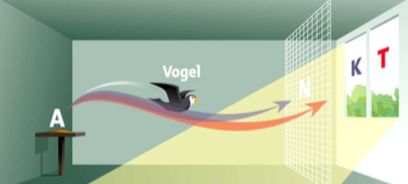
Bird
During the approach test, a bird can either fly towards a control pane (K) or the Ornilux test pane (T). Tests are used to document which proportion of the birds flew towards the control pane and therefore recognised the Ornilux glass as an obstacle. The birds are stopped by a special net (N) well in advance of the panes, thus ensuring that they are not harmed during the test.

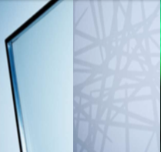
Practically invisible to the human eye – the fine web-like structure of Ornilux mikado (left). The structure is only clearly visible to animals that are sensitive to ultraviolet light (right)

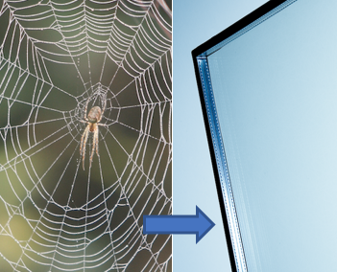
The technology behind Ornilux mikado is inspired by spider webs. The webs reflect UV light, which is recognized by most bird species, allowing them to fly safely around the filigree structures.

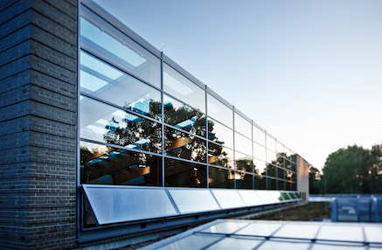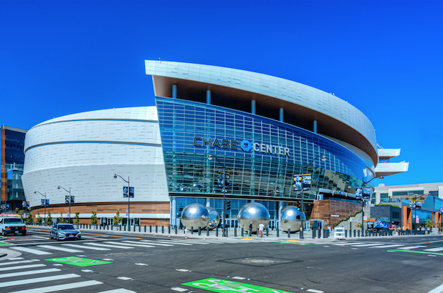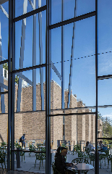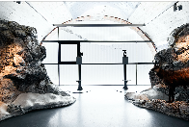
Glass from the Ornilux range has already proven successful in countless projects around the world: (from the left, Chase Arena, San Francisco (USA), Vassar College, Poughkeepsie (USA), Karwendel Nature Information Centre, Berchtesgaden (Germany)).

