Division: Glass Construction | Date: 11.01.2021 |
Text and photo: https://www.der-pressedienst.de/architektur-bauen/intl-architecture/

arcon introduces new Glas Visualizer

Because first impressions are crucial

Easy to use online visualization tool for architects and building designers / Test the look of all available products on facade mock-up free of charge / Various lighting moods configurable

With just a few clicks, arcon’s new Glas Visualizer lets you test out the visual appeal of a facade surface. The practical visualization tool is available free of charge on arcon’s website and greatly simplifies the consultation and decision-making processes. Because a picture is worth a thousand words.

For large facade areas in particular, the choice of glazing plays a crucial role, because the glass and/or its coating define the character of a building, which changes depending on the light conditions. The new Glas Visualizer was developed by arcon to allow architects, building designers and their clients to get a first impression of the effect of a specific glazing option on the building frontage.

Unsing the visualization integrated on the company's website at https://www.arcon-glas.de/campus/arcon-glas-visualizer, all currently available arcon products can be integrated into a facade mock-up in just a few clicks. The user can also switch between various light conditions (sunny or overcast). The Glas Visualizer provides support with the choice of glazing while at the same time helping reduce the number of original samples, which can sometimes involve a lot of time and effort.

“When developing the online visualization tool we focused on making it as realistic as possible,” explains Simon Potts, Plant Manager Coating at arcon. “Because the first impression often points the way. The more realistic the representation the sooner the people involved in a construction project can narrow down their favorites.” And the quicker the consultation and decision-making processes can reach an outcome. “This saves time and money,” Potts concludes. There is no charge for using the Glas Visualizer.

About arcon:
arcon offers a broad array of highly effective magnetron coatings on all kinds of glass substrates, from float glass to laminated or body-tinted glass and various types of tempered safety glass. Today, arcon is one of Europe's leading glass producers. Its product range includes premium products in the field of coated architectural glazing like high-performance thermal insulation coatings, solar control coatings and other special types of glass. As a member of the Arnold Glas Group, arcon is in a position to put synergies to work for its customers and offer complete solutions.
www.arcon-glas.de

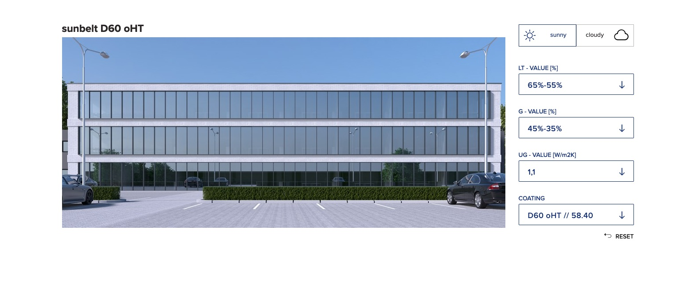
Caption: Architects and building planners can use arcon's Glass Visualizer to get a first impression of the visual effect of a glass coating.

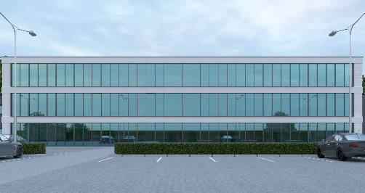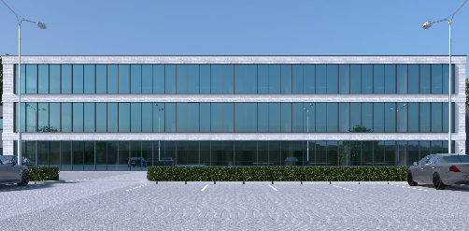
Caption: The arcon Glas Visualizer allows different light conditions (left: overcast, right: sunny) to be simulated on a glass facade.

Contact: PR contact:

arcon Flachglas-Veredlung GmbH & Co. KG ecomBETZ
Andreas Winter Klaus Peter Betz
Industriestraße 10 Goethestraße 115
91555 Feuchtwangen 73525 Schwäbisch Gmünd
Tel. +49 (0)9852 6700-0 Tel. +49 (0)7171 92529-96
Email: andreas.winter@arnold-glas.de Email: k.betz@ecombetz.de

