More powerful and precise grinding machines require superb grinding wheels and dressing rolls
Machine, grinding wheel, and dressers—On the road to top performance, the DVS TECHNOLOGY GROUP and its subsidiaries are offering a turnkey solution for internal and bore grinding as a milestone for future mobility.

The iCompact from Buderus combines a modern design, a solid construction, and the most efficient hard finishing technologies all within a small footprint of only 7.5 m². And to get the most out of the machine, the abrasives specialists at DVS NAXOS DISKUS have developed an entire series of vitrified bonded diamond and CBN grinding wheels that are tailored to the grinding process required for the iCompact, which provides the foundation for further increasing the precision and repeatability of the machine tool processes. The wheels also enable the processing of materials with hardnesses well in excess of 60 HRC. And they also help to significantly decrease the dressing and profiling intervals on the iCompact. Optionally, the grinding wheels can be manufactured straight and with a coarse profile in order to reduce the time required for wheel changeovers. This further increases the productivity of the iCompact.
How cubic crystalline boron nitride is revolutionizing internal grinding
DVS NAXOS DISKUS offers CBN grinding wheels that maximize the service life when it comes to grinding bores. In addition to diamonds, CBN (cubic boron nitride) is another super-hard abrasive. The CBN grinding wheels from DVS NAXOS DISKUS have stood the test of time in real-world applications over many years and combine high process stability with higher cutting performance. “Our customers are very pleased with the results. And compared to conventional abrasives, such as corundum or silicon carbide, these grinding wheels have a much longer service life and never lose quality,” reports Mario Arnold, Technical Manager and member of the management board of DVS NAXOS DISKUS at the Butzbach plant. In addition, the time-consuming dressing cycle is extended many times over when grinding with vitrified bonded CBN grinding wheels. “What’s more, we adapt the specifications individually for the various applications of our customers. This allows us to design the right grinding tool for our customers for every application,” according to Arnold.
DVS NAXOS DISKUS offers different disc variants that can be used with the new abrasive grain generations for internal grinding. When it comes to internal grinding, CBN offers another advantage over corundum: “Tools made of CBN can be produced in small diameter ranges. Corundum grinding wheels max out their geometric production limits faster,” the product manager explains.
The first users of this technology are from the DVS TECHNOLOGY GROUP, where the quality requirements are very strict. “We see a lot of opportunity in the E-mobility sector and with manufacturers of industrial gears,” Arnold points out. “Electric drives require gears and shafts with extreme surface qualities. This can only be achieved with high-quality internal grinding tools.”
Optimum grinding solutions for many industrial sectors
Vitrified bonded CBN and diamond grinding wheels made in-house at NAXOS DISKUS are the best choice when highly efficient production is critical for the machining of individual or series parts for the automotive industry, hydraulic components, injection nozzles for combustion engines, products made of technical ceramics, parts that are coated using the HVOF process, and numerous components for future mobility.
The product range from DVS NAXOS DISKUS includes cylindrical grinding wheels or grinding wheels based on user drawings. They can be mounted via the bore or on a steel or carbide spindle. To find the ideal grinding solution in each case, the application engineers at the abrasives specialist work in close cooperation with the customer.
Efficient dressing processes
Dressing tools made of CBN and diamond complement the product portfolio of DVS NAXOS DISKUS. They are used for the economical dressing of grinding wheels in different bonding systems. When used in the Buderus iCompact, they offer maximum accuracy in the dressing process. Grinding wheel dressing produces precise concentricity and a correct geometric shape on the grinding wheel. Dressing is also used for profiling or calibrating grinding wheels. It also removes impurities from the grinding wheels caused by material abrasion and the blunted abrasive grits, and it lays bare sharp abrasive grits. This reduces heat generation during the grinding process and keeps the required removal rate steady.
Diamond dressing rolls have different diamond designs. Today, industrial diamonds made of MKD, CVD, and PCD are increasingly taking the place of natural stones. This is due to the fact that the defined shape of industrially manufactured diamonds ensures a steady and reproducible quality over the entire service life. But CNC-controlled form rolls are used particularly for small and medium-sized series or prototype applications because CNC control facilitates changes in the production process. This keeps the workpiece-related dressing costs down and drops the “price per piece” to a minimum.
Since the introduction of CNC-controlled dressing processes, the number of CBN and diamond form dressing rolls on the market has increased significantly. So for users it has become virtually impossible to select adequately between all available variants.
This is why the abrasive plants in close cooperation with the sister companies DVS Tooling and Buderus Schleiftechnik are looking to reduce the wide variety available. The goal is to keep the warehousing effort feasible and enable cost-effective tool production. The companies of the DVS TECHNOLOGY GROUP are thus optimizing the grinding processes of their customers in terms of economics.
Forming rolls in natural and CVD diamond designs are mainly used for conventional grinding wheels. DVS NAXOS DISUKS is also offering various models of self-sharpening tools for extremely tough grinding wheel applications. Through the precise coordination between the dressing tool and the machine-integrated dressing spindle, they enable the highest concentricity accuracy.
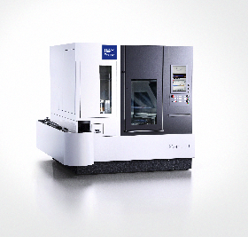

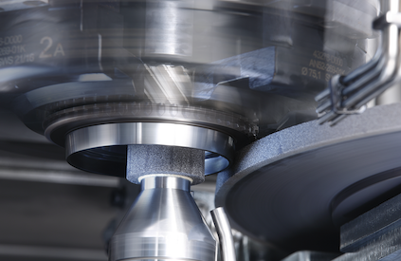

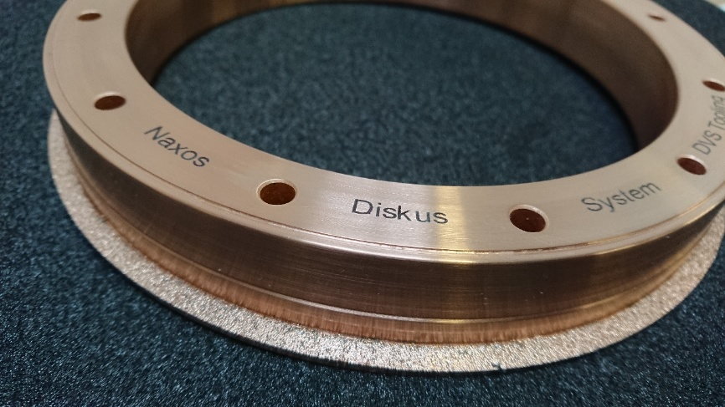

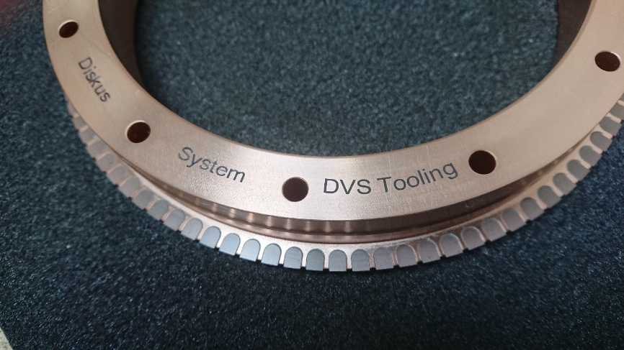

* HVOF – high velocity oxygen fuel spraying, is a thermal coating process used to finish surfaces.

