Division: Technik | Date: 11/24/2022 | Text und photo under http://www.der-pressedienst.de/technology

Chocal launches "easily compostable" packaging:

"For a world without plastic waste"

A crucial innovation at packaging specialist Chocal: "We have developed a technology that can be used to mould sustainable packaging made of paper with barrier functions as well as transparent cellulose-based films," says Chocal CEO Dr.-Ing. Alexander von Niessen, adding: "We are thus making an enormous contribution to a world without plastic waste."

The Chocal packaging solution is revolutionary: the packaging materials are made of transparent cellulose materials specially developed by the company, Chocal Natural Fibres (CNF) or of coated, formable papers, Chocal Paper Fibres (CPF). Thanks to this technology, both packaging materials are individually formable, resulting in stable and food-safe products. Chocal packaging features home compostability or recyclability, making it a clear sustainable competitor to PLA packaging, which is not safely biodegradable. "Consumers, however, have been led to believe that PLA packaging is ecologically sound. But ultimately, like any classic plastic bag or hard plastic packaging, they are also responsible for microplastics in the environment," says von Niessen.
Products made from PLA only decompose after 80 years
The currently popular PLA packaging consists of polylactic acid, which is also based on renewable raw materials, and is advertised as being "biodegradable“. But this detail turns out to be problematic on closer inspection, emphasizes von Niessen. Because biodegradable initially means not much more than that the material only decomposes under certain conditions. "In the wild, it takes around 80 years for PLA to decompose. That roughly corresponds to the time it takes for a commercially available tetrapack to decompose," the doctor of engineering knows, adding, "During this long time, PLA contributes to environmental pollution from plastics and microplastics - and is thus no different from plastics made from petroleum."
Products made from PLA should therefore not be thrown into nature or end up in organic waste as well as home compost. "Only theoretically could PLA be disposed of in an environmentally friendly manner with considerable effort and expense. Constant temperatures of 55° to 70° Celsius and moisture in interaction with microorganisms would be the prerequisite for this," explains the Chocal boss, thus finally putting an end to the fairy tale of easily and quickly compostable plastic. Conclusion: "Realistically speaking, the use of PLA is not an adequate means of reducing plastic waste. With regard to PLA, biodegradability remains a theory that is virtually non-existent in practice."
Chocal declares war on plastic waste
Packaging specialist Chocal is declaring war on plastic waste "because the packaging industry has a key role to play," Chocal's managing director is certain. "Half of all plastic waste originates in packaging." A genuine sustainable solution to this problem is therefore equivalent to a revolution in the industry. "We have found it," von Niessen proudly proclaims. The Chocal solution combines the in-house technology for producing preformed packaging, which has been tried and tested a million times over, with naturally compostable materials: "We use papers and transparent films based on natural raw materials. Plant waste can also be used as a material base," says von Niessen.
Paper packaging can be individually shaped and printed
The microplastic problem does not exist with packaging made of barrier paper or cellulose fiber films. Even if they are not fed into the regular waste management cycle, they decompose in an environmentally neutral way without any further technical effort. Like conventional paper, Chocal's barrier papers are made from renewable wood fibers. They have a coating of biopolymers that makes the paper impermeable to water vapor, oxygen, odors or fats. As a result, the packaging has all the properties required by standards and directives, making it much more sustainable and environmentally friendly. "With the process we have developed, various barrier materials can be used - depending on the requirements. Of course, the paper packaging can be designed in different colors and printed with both text and images," says von Niessen.
Whether paper or fiber packaging - both are truly sustainable
That also applies to fiber packaging, which Chocal has in its range as another sustainable packaging solution in addition to paper packaging, he said. "They can be printed brilliantly and can also be combined with barrier layers. Whether it's take-away food packaging, yogurt cup lids, beverage cup lids or blister packaging for food, electronics or hygiene products: They are all compostable or can be recycled back into the raw material cycle," emphasizes the Chocal managing director.

Contact:
CHOCAL Packaging Solutions GmbH ecomBETZ PR GmbH
Waldemar Geng Klaus Peter Betz
Tel. +49 (0) 7171 1009-388 Tel. +49 (0) 7171-92529-90
info@chocal.de k.betz@ecombetz.de

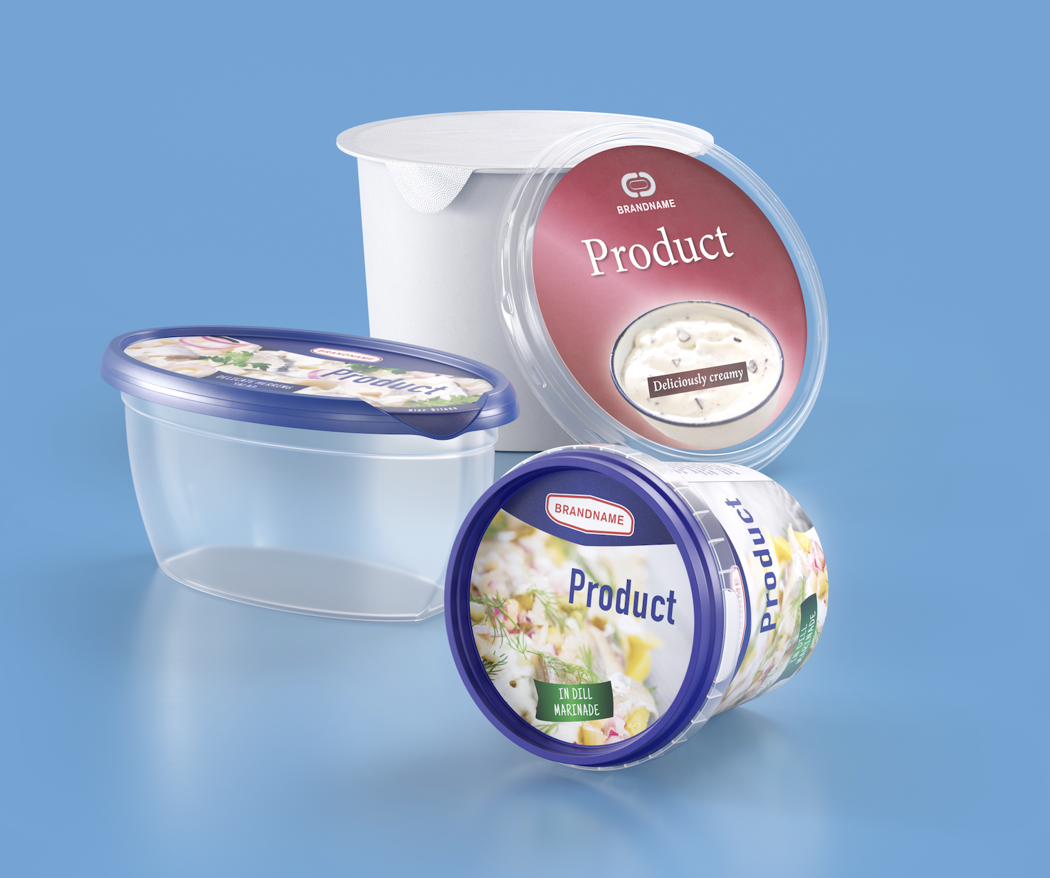

Caption: The alternative to PLA is called CNF or CPF: Thanks to Chocal‘s technology, the materials based on Chocal Natural Fibre (CNF) or paper (CPF) can be transformed into modern packaging solutions and are compostable or can be fed into the recycling process. In this way, no environmentally harmful microparticles are produced. (Image source: Chocal)

