Ressort: Technik | Datum: 07.02.2023 | Text and images at https://www.der-pressedienst.de/technik/technology/

Swabian company wants a world without plastic waste

Classic plastic packaging is running out of arguments

Formable, printable packaging that can be used for products from all industries - this is now possible with Chocal Paper Fibres (CPF). Packaging specialist Chocal Packaging Solutions has developed a technology that allows sustainable and fully recyclable packaging to be molded into individual shapes. "And it's purely paper-based, so we can really talk about recyclability," says Chocal Managing Director Dr.-Ing. Alexander von Niessen.

Plastic packaging shapes consumer worlds around the globe and is responsible for polluted oceans, food contamination, and damage to health and the climate. Be it blister packs for batteries or lip balm, containers or trays for vegetables or convenience products - the packaging covers are almost always intended for single use. This plastic waste threatens nature, humans and animals for many decades. And despite all the efforts made to date in terms of waste avoidance, according to an OECD study, around 1,000,000 tons of new plastic waste are produced worldwide every day, which is equivalent to the weight of 100 Eiffel Towers (!). Only nine percent of this is recycled.

"With our developments, we are declaring war on plastic waste," says Dr.-Ing. Alexander von Niessen, Managing Director of packaging specialist Chocal Packaging Solutions, referring to Chocal Paper Fibres (CPF). This is a new type of material consisting of coated, formable papers. This revolutionary technology enables not only extremely stable, but also food-safe packaging that can be individually shaped.

CPF is truly compostable
All CPF variants are also truly compostable or can be disposed of in the waste paper garbage can and thus reprocessed into paper fiber. These properties make CPF significantly more sustainable than, for example. Packaging made from polylactic acid (PLA), currently the most common alternative to petroleum-based plastics. "But with these, consumers are led to believe they are biodegradable. Ultimately, like any classic plastic bag or hard plastic packaging, they are also responsible for microplastics in the environment, because PLA only decomposes in the wild after about 80 years and the property of compostability is currently only given under laboratory conditions," says von Niessen. Even Styrofoam decomposes after only 50 years. "And no one would call Styrofoam environmentally friendly today," says the engineer.
"We must finally stop lying to ourselves," criticizes the Chocal managing director. Today, recycling means downcycling in almost all cases. That is, a formerly pure raw material becomes a significantly inferior raw material according to quality. "And this downcycled plastic can no longer be easily used as granulate for further injection molding applications."

Open to design and aesthetics
For von Niessen, the packaging industry plays a key role in the fight against plastic waste, because "half of all plastic waste originates in packaging." If they were to switch to CPF solutions, millions of tons of plastic waste could be prevented immediately. And the functional and aesthetic arguments against packaging made of paper-like materials that have been put forward up to now are now coming to nothing: because Chocal barrier papers have a coating of real "easy-compostable" biopolymers that make the paper impermeable to water vapor, oxygen, odors or fats. This makes them suitable for highly demanding food packaging applications. Von Niessen is open to design and aesthetic requirements from a wide range of industries: "Our papers can be brilliantly printed with colors and text and, thanks to our technology, can also be individually formed in depth."
Whether it's take-away food packaging, beverage cup lids, blister packs or miniature containers for cosmetics and hygiene products: They are also 100 percent recyclable or fully compostable in the home garden - and consumers can check for themselves. "A blister or a lid can become high-quality paper products again. This brings us a significant step closer to the circular economy," emphasizes the Chocal managing director.

About Chocal Packaging Solutions:

Chocal offers a wide range of sustainable packaging solutions - aesthetic, with optimal product protection and good for the planet. From lids, trays and hollow figures to blisters or trays - Chocal packaging is used in all industries. Packaging machines from Chocal are fully digitized, highly modular and available in different formats and performance classes. Chocal Packaging Solutions was founded in 1931 as an artisan metal molding company and is now a world leader in the development of sustainable molded packaging.

More at www.chocal.com

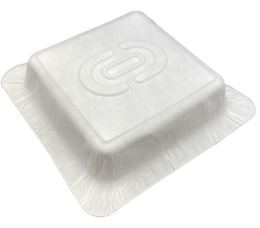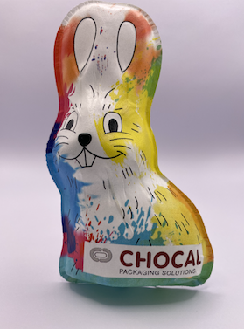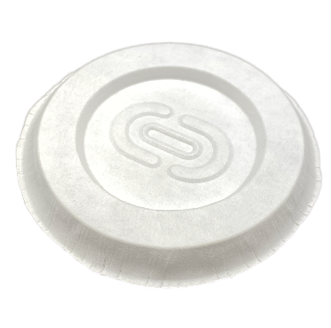

Image text: The alternative to classic plastic packaging is called Chocal Paper Fibres (CPF): thanks to Chocal technology, the paper-based materials can be transformed into modern packaging solutions, easily printed, and can be one hundred percent recycled or composted. In this way, no environmentally harmful microparticles are produced. (Image source: Chocal)

CONTACT:
CHOCAL Packaging Solutions GmbH ecomBETZ PR GmbH
Waldemar Geng Klaus Peter Betz
Tel. +49 (0) 7171 1009-388 Tel. 07171-92529-90
info@chocal.de k.betz@ecombetz.de

